WHERE VALUE LIVES
Executive Toolkit
Relationship Architecture Toolkit
A practical toolkit for mapping, evaluating and strengthening strategic relationships across the customer’s organisation.
Supporting Chapter 8
Author: Fred Mills
Website: millsconsultancy.com
Publication Code: WVL-TK-08-v1.0
Copyright © Fred Mills.
Why Relationship Architecture Matters
Strategic value is rarely protected by one relationship.
The strongest customer relationships are deliberately designed. They do not depend on one friendly contact, one senior sponsor or one person who happens to like working with you.
Relationship architecture is the disciplined work of mapping, evaluating and strengthening the network of relationships that connects your organisation with the customer’s organisation. It helps you understand who influences value, who shapes decisions, who carries risk, and where the next relationship investment should be made.
This toolkit supports Chapter 8 of Where Value Lives. It is designed for practical use with strategic accounts, key accounts and complex customer relationships where value is created across many stakeholders.
Challenge Your Thinking: If your most important customer relationship disappeared tomorrow, would the account still be secure, understood and growing?
Relationship Architecture Model
Five layers that make the relationship visible.
The Relationship Architecture Model breaks the customer relationship into five connected layers. Each layer reveals a different part of the account: who matters, how influence moves, where risk sits, how relationships are developed, and how strategic conversations are sustained.
- Layer 1: Stakeholder Coverage - identifying the people who matter across the customer’s organisation.
- Layer 2: Influence and Decision Flow - understanding how decisions are shaped formally and informally.
- Layer 3: Dependency and Risk - spotting over-reliance on a single person, department or relationship type.
- Layer 4: Relationship Development - building trust before asking for commitment.
- Layer 5: Executive Engagement - creating senior-level relevance through value-led conversations.
Executive Insight: Relationship architecture turns relationship management from a personality-led activity into a strategic account discipline.
Relationship Architecture Wheel
A visual way to keep the whole relationship system in view.
Use the wheel as a working map. It reminds you that coverage, influence, risk, development and executive engagement need to be managed together. Weakness in one layer eventually affects the others.
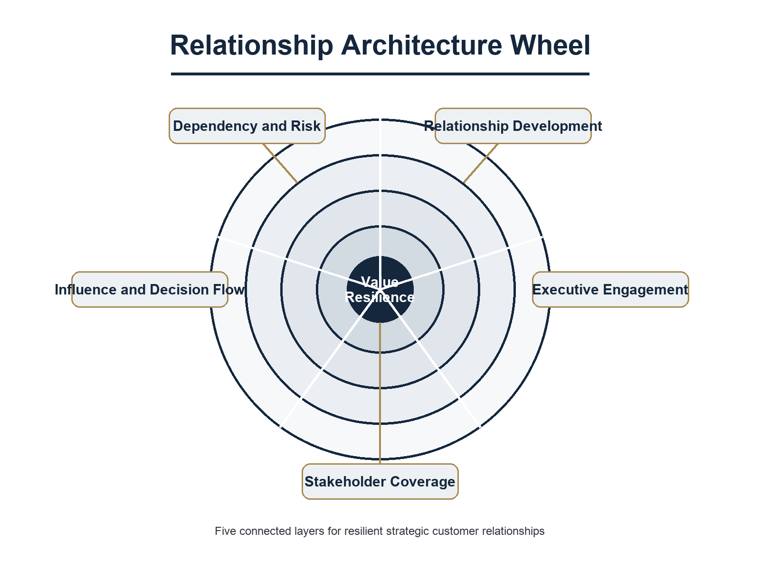
The Relationship Architecture Wheel connects the five layers of a resilient strategic relationship.
Stakeholder Coverage Map
Identify who is known, unknown, strong, weak or missing.
A strategic account should not depend on a thin set of contacts. Use this map to review relationship coverage across functions, seniority levels and decision roles.
Challenge Your Thinking: Where are you assuming coverage because one person is helpful, visible or easy to contact?
Stakeholder / Function | Current Contact | Relationship Strength | Role In Value | Next Action
Executive sponsor
Economic decision maker
Operational owner
Procurement / commercial
Technical or specialist influencer
Front-line user group
Relationship Influence Matrix
Separate access from influence.
Not every accessible stakeholder is influential, and not every influential stakeholder is accessible. Use this matrix to decide where relationship effort should be focused.
Common Mistake: Confusing frequency of contact with strategic influence. A regular contact may be important, but they may not shape the decision.
Stakeholder | Access Level | Influence Level | Current Position | Required Shift
 | High / Medium / Low | High / Medium / Low | Supporter / Neutral / Concerned
 | High / Medium / Low | High / Medium / Low | Supporter / Neutral / Concerned
 | High / Medium / Low | High / Medium / Low | Supporter / Neutral / Concerned
 | High / Medium / Low | High / Medium / Low | Supporter / Neutral / Concerned
 | High / Medium / Low | High / Medium / Low | Supporter / Neutral / Concerned
Relationship Dependency Risk Assessment
Find the relationship risks before the customer finds them for you.
The Relationship Risk Triangle asks whether your account is exposed through people, information or influence. A relationship can feel healthy while still being fragile.
Risk Area | Question | Score 1-5 | Evidence | Action
Person dependency | Do we rely too heavily on one contact?
Information dependency | Do we hear only one version of the customer’s priorities?
Influence dependency | Are key decisions shaped by people we do not know?
Transition risk | Would a change of role or sponsor weaken the account?
Value visibility risk | Do enough stakeholders understand the value we create?
Scoring Instructions
Score each risk area from 1 to 5, where 1 means low exposure and 5 means serious exposure. Add the scores to identify whether urgent relationship strengthening is required.
Score Band | Interpretation
5-10 | Low visible dependency risk. Continue strengthening coverage.
11-17 | Moderate dependency risk. Prioritise the weakest relationship layer.
18-25 | High dependency risk. Create an immediate relationship resilience plan.
Stakeholder Development Planner
Apply the Relationship Development Cycle.
Stakeholder development is not the same as stakeholder contact. The Relationship Development Cycle moves from relevance, to trust, to insight, to value, to commitment.
Use the Relationship Investment Principle: invest before you expect return. Give Before You Ask is not a slogan; it is a discipline.
Stakeholder | Current Relationship Stage | Value We Can Give First | Desired Next Commitment | Owner / Date
 | Unknown / Known / Trusted / Strategic
 | Unknown / Known / Trusted / Strategic
 | Unknown / Known / Trusted / Strategic
 | Unknown / Known / Trusted / Strategic
Strategic Relationship Meeting Planner
Plan meetings around value, not updates.
The 80:20 Conversation Principle means the customer should spend more time exploring their priorities, pressures and desired outcomes than listening to your update. Prepare questions that reveal what matters.
Challenge Your Thinking: What would make this meeting useful even if the customer bought nothing from you immediately?
Meeting Element | Preparation Notes
Purpose of the meeting
Customer priority to explore
Value insight to bring
Questions to ask
Commitment to seek
Follow-up action
Quarterly Relationship Review
Make relationship health part of account governance.
A quarterly review should look beyond revenue, pipeline and activity. It should test the strength and spread of relationships across the customer’s organisation.
Review Area | Current Evidence | Concern | Decision / Action
Coverage
Influence
Dependency risk
Executive engagement
Value visibility
Next quarter focus
Executive Engagement Planner
Earn senior attention through strategic relevance.
Executive engagement is not about gaining access for its own sake. It is about connecting your contribution to the customer’s strategic agenda.
Executive | Likely Agenda | Business Outcome They Care About | Useful Insight To Bring | Next Step
Relationship Opportunity Planner
Turn stronger relationships into better value creation.
Relationship architecture is not only defensive. Stronger relationships reveal opportunities to solve more important problems, improve customer outcomes and create value that competitors cannot easily see.
Relationship Opportunity | Stakeholder Connected To It | Value Potential | First Useful Action | Owner
Relationship Architecture Scorecard
Score the strength of the relationship system.
Use this scorecard to create a practical baseline. The score is less important than the conversation it creates.
Dimension | Score 1-5 | Evidence | Improvement Action
Stakeholder coverage
Influence visibility
Dependency risk control
Relationship development discipline
Executive engagement quality
Value visibility across the account
Scoring Instructions
Score each dimension from 1 to 5. A total below 18 suggests the relationship architecture needs focused attention. A total above 24 suggests a strong platform, but still check for hidden dependency risk.
Score Band | Interpretation
6-17 | Fragile. Prioritise coverage, risk and influence visibility.
18-23 | Developing. Strengthen weaker layers and review quarterly.
24-30 | Strong. Protect momentum and executive relevance.
Relationship Architecture Action Plan
Convert insight into movement.
Select three actions that will materially improve the resilience and value of the account relationship over the next quarter. Keep the plan focused enough to be completed.
Priority | Action | Relationship Layer | Owner | Due Date | Success Measure
1
2
3
AI Prompt Pack
Use these prompts to prepare, challenge and improve your relationship architecture.
These prompts are designed to help you think more clearly. Do not paste confidential customer information into any AI system unless your organisation permits it.
PROMPT 1
Strategic Account Prompt 1
Act as a strategic account advisor. Review the following stakeholder list and identify gaps in relationship coverage, influence visibility and dependency risk. Suggest three relationship-building priorities for the next quarter.

PROMPT 2
Strategic Account Prompt 2
Using the Rule of Three, help me identify whether we have enough relationship coverage across executive, operational and commercial stakeholders in this account.

PROMPT 3
Strategic Account Prompt 3
Review this meeting plan and improve it using the 80:20 Conversation Principle. Make the questions more customer-centred and value-led.

PROMPT 4
Strategic Account Prompt 4
Assess this account against the Relationship Risk Triangle: person dependency, information dependency and influence dependency. Identify the highest-risk area and recommend practical actions.

PROMPT 5
Strategic Account Prompt 5
Help me create a Give Before You Ask plan for a stakeholder we need to develop. Suggest useful insights, introductions or support we could offer before asking for commitment.
Key Principles
The discipline behind the tools.
- Strategic relationships must be designed, not left to chance.
- Access is not the same as influence.
- One strong relationship can hide a weak account architecture.
- The Rule of Three reduces dependency by building relationship coverage across levels and functions.
- The Relationship Investment Principle means giving value before asking for commitment.
- The 80:20 Conversation Principle keeps the customer’s priorities at the centre of strategic meetings.
- Executive engagement must be earned through relevance.
Final Thoughts and Related Publications
Where relationship strength becomes value resilience.
Relationship architecture matters because value lives in the customer’s world, not only in your product or service. The more clearly you understand the customer’s network of influence, priorities and risk, the better you can protect and grow the relationship.
Use this toolkit as a working document. Revisit it quarterly, update it when stakeholders change, and use it to guide better conversations.
- Related publication: Where Value Lives.
- Related chapter: Chapter 8 - Relationship Architecture.
- Related resource family: Executive Toolkit.
Challenge Your Thinking: Which relationship will you strengthen first, and what value will you give before you ask for anything in return?

